Installation MODBus Set GA5903

Function: This wire set is a tool to make communication trough Modbus possible. The set can be applied to all heaters quipped with an EBM 966 control board and enables a connection between the Modbus Interface and the heater.

Installation:
Connection to the control board:
- Insert the 4-pole plug of the cable supplied into terminal J16 of the control board.

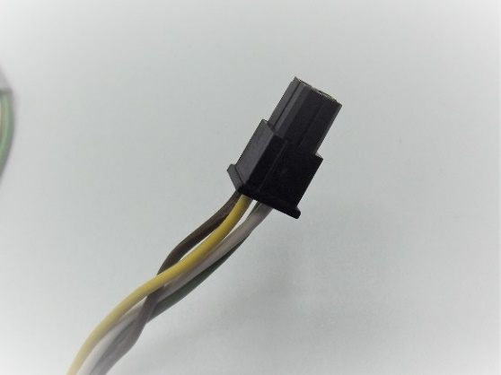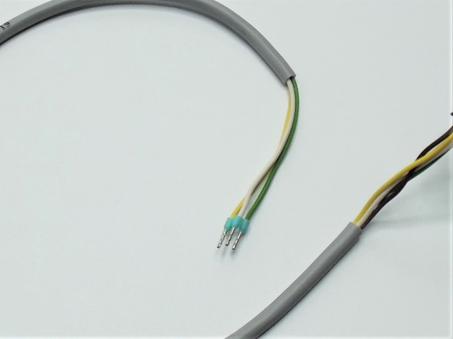

Connection to heater’s terminal support:
- Screw the white connector supplied somewhere on the terminal support or let it hang loose.
- Attach the the sticker underneath the connector as illustrated in the picture.
- Connect the yellow wire to A/+
- Connect the white wire to B/-
- Connect the green wire to PE (GND)

